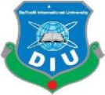
Daffodil International University

Department of Electrical and Electronic Engineering

Faculty of Engineering

Notice

Students of the Department of Electrical and Electronics Engineering are hereby notified that the Improvement Examination, Fall 2021 and who couldn’t attend Final term Examination, Fall 2021 will be held from 25.01.2022.
All the students are advised to submit application to the respective EEE office with the signature of their course teacher within 23.01.2022
NB: The student who obtained below Grade B (3.00) will be eligible for the Improvement exam. No student will be allowed without application with respective course teacher signature.

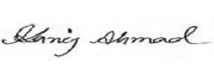
Kanij Ahmad
Sr. Lecturer, Department of EEE.
Member of Exam Committee
Treasurer, EEE Club, DIU
Faculty of Engineering.
Daffodil International University.
Contact No. 01720694515

